**Mindset Quiz**

**What kind of mindset do you have?**



*Directions: For each question, mark the box next to how you feel about the statement.*

1. **You can’t change your intelligence very much.**

​Strongly Agree ​​Agree ​​Disagree ​​Strongly Disagree

1. **You can always change basic things about the kind of person you are.**

​Strongly Agree ​​Agree ​​Disagree ​​Strongly Disagree

1. **Any one can become a musician or get into the music business.**

​Strongly Agree ​​Agree ​​Disagree ​​Strongly Disagree

1. **Only a few people will be truly good at sports-- you have to be “born with it.”**

# ​Strongly Agree ​​Agree ​​Disagree ​​Strongly Disagree

1. **Math is much easier to learn if you are male or maybe come from a culture that values math.**

​Strongly Agree ​​Agree ​​Disagree ​​Strongly Disagree

1. **No matter what kind of person you are, you can always change yourself.**

​Strongly Agree ​​Agree ​​Disagree ​​Strongly Disagree

1. **Trying new things is stressful for me and I avoid it.**

​Strongly Agree ​​Agree ​​Disagree ​​Strongly Disagree

1. **Some people are good and kind, and some are not-- people don’t usually change.**

​Strongly Agree ​​Agree ​​Disagree ​​Strongly Disagree

1. **I appreciate when teachers or other people give me ideas about ways I can improve.**

# ​Strongly Agree ​​Agree ​​Disagree ​​Strongly Disagree

1. **All people, unless they have a brain injury or birth deformity, are capable of the same amount of learning.**

​Strongly Agree ​​Agree ​​Disagree ​​Strongly Disagree

1. **People are basically good, but sometimes make terrible decisions.**

​Strongly Agree ​​Agree ​​Disagree ​​Strongly Disagree

1. **You can learn new things, but you can’t really change how intelligent/smart you are.**

# ​Strongly Agree ​​Agree ​​Disagree ​​Strongly Disagree

1. **You can do things differently, but the important parts of who you are can’t really be changed.**

​Strongly Agree ​​Agree ​​Disagree ​​Strongly Disagree

1. **An important reason why I do my school work is that I like to learn new things.**

​Strongly Agree ​​Agree ​​Disagree ​​Strongly Disagree

1. **People who are very smart do not need to try hard.**

# ​Strongly Agree ​​Agree ​​Disagree ​​Strongly Disagree

**Adapted from:**

**Dweck, C.S. (2006)**​ ***Mindset: The new psychology of success***​**. New York House Inc. Smithtown Central School District.** ​***Mindset Quiz***​**.**

**http://www.smithtown.k12.ny.us/wp­content/uploads/2014/07/Mindset­Quiz.pdf**

**Scoring instructions for tutors:**

Growth Questions - (questions that support a growth mindset): 2,3,6,9,10,11,14 1. Strongly Agree-3 points 2. Agree-2 points 3. Disagree-1 point 4. Strongly Disagree- 0 point

Fixed Questions (questions that support a fixed mindset): 1, 4, 5, 7,8,12,13,15 1. Strongly Agree-0 point 2. Agree-1 point 3. Disagree-2 points 4. Strongly Disagree-3 points

# Strong Growth Mindset 45-33 points Growth Mindset with some Fixed Ideas 32-24 points Fixed Mindset with some Growth Ideas 23-15 points Strong Fixed Mindset 14-0 points

**General strategies for all students:**

* Focus on the value of learning and what can be gained.
* Provide tasks that are meaningful to children, given their interests and environments.
* Present your student with realistic but challenging tasks and place the emphasis on mastery of the skill, rather than performance.
* Use encouraging language and help students use this language to describe their effort.

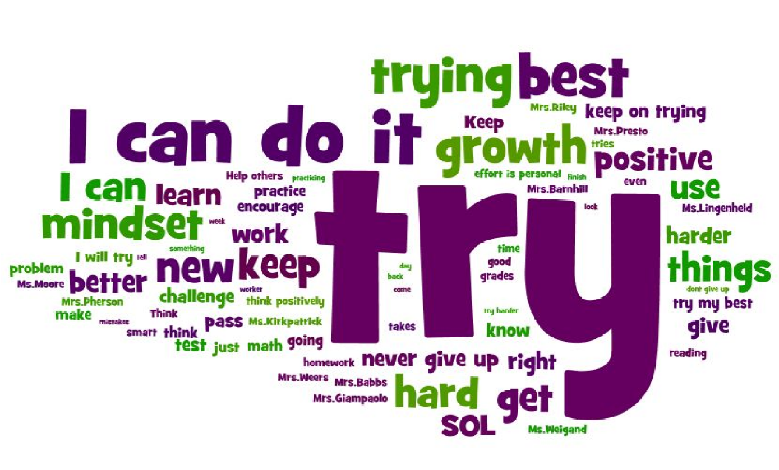

**Adapted from:**

**Dweck, C.S. (2006)**​ ***Mindset: The new psychology of success***​**. New York House Inc. Smithtown Central School District.** ​***Mindset Quiz***​**.**

## http://www.smithtown.k12.ny.us/wp­content/uploads/2014/07/Mindset­Quiz.pdf